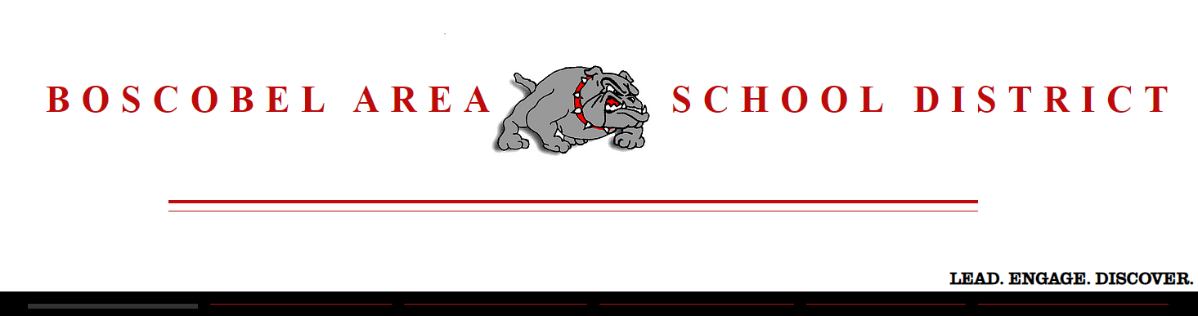
Academic and Career Plan

OUR VISION:
“Lead. Engage. Discover.”

OUR MISSION:
“Developing today’s child for tomorrow’s world”

Per Wisconsin DPI, Academic and Career Planning, or ACP, is a student-driven, adult-supported process in which students create and cultivate their own unique and information-based visions for post-secondary success, obtained through self-exploration, career exploration, and the development of career management and planning skills.

Click on the link below to view a short video explaining ACP and why it has become an important part of education here at Boscobel.

Why ACP Matters

PLAN OVERVIEW

WHAT WE DO TO MAKE STUDENTS COLLEGE & CAREER READY

- Course offerings
- Professional certifications
- Partnerships with local businesses
- Individualized mentors
- CTE organization
- Resource planning time
- Career awareness-elementary level
- Courses: (Careers and Personal Finance)

Xello (formerly known as CAREER CRUISING) 26.03(1)(c)(1) 26.03(2)(b)(c)(1) 26.03(3)(c)

The link for the standards that Career Cruising satisfies: Career Cruising and the ASCA National Model Career Development Standards for RAMP.

At Boscobel, students begin developing their ACP as early as sixth grade by utilizing a software program known as “Xello”. Each student will create their own account and add information to this account throughout their middle school and high school career. At the beginning of the school year, the sixth grade students will answer a series of questions related to their interests and learn of at least one career that will fit those interests. They will also gain the knowledge of how they learn (learning style) following the Career Cruising Recommended Portfolio Completion Standards and Scope and Sequence.

Freshmen and Sophomores will work through the activities in Xello during the Careers Class. The careers teacher will work with them on career planning including, why people work, the conditions under which people work, the levels of training and education needed for work, common expectations for employees in the workplace, and how expectations at school are related to expectations in the workplace.

Juniors and seniors will work with the Personal Finance teacher during the Consumer Math class. They will continue through Xello according to the Scope and Sequence and completion standards recommended by DPI.

Freshman and Seniors will have their needs of the Scope and Sequence of Xello met by their individual homeroom teacher.

See the Grade-By-Grade Activity Guide included in this document for more information on what students will develop in this program at each grade level.

RESOURCE TIME/INDIVIDUALIZED MENTORS 26.03(3)(a)(b) 26.03 (2)(c)(3) 26.03 (3)(a)

HIGH SCHOOL students will receive help with their ACP plan during the ACP time which will occur twice a month during homeroom time. Students will have the opportunity to discuss career clusters based on their assessments taken in Career Cruising including the Matchmaker tool.

As sophomores, students will meet with the school counselor to review and update the ACP and with the school counselor, students view and update ACP documents. Completed ACPs are stored in the e-portfolio of Xello. Throughout high school each student's ACP process is continually changing. Throughout the twelve years of the school, students will explore various academics, clubs, sports, work and volunteer experience. Ideas change over the years and new experiences will help guide students through their paths.

MIDDLE SCHOOL students will be divided into groups of eleven to fifteen with an advisor working specifically with each group. Each group will have students from all three grade levels and students will stay with the same advisor throughout middle school. The Advisors assigned to middle school include the following teachers: reading, math, science, English, resource, social studies, and intervention.. They will utilize a resource binder and follow a schedule to support the development of age appropriate soft skills as well social skills as related to academic and career planning.

PARENT/FAMILY INVOLVEMENT 26.03 (1)(b)(1)(2)(3)

Because Boscobel has chosen to use the software application, Xello, families can explore the student's individual account. What is Career Cruising for Parents is a website that explains more about this unique tool. It's a wonderful site that really allows students to connect their future career options with connecting it to future programs and high school courses.
Students and parents can start the process by just talking about the student's interest and thoughts about future jobs.

Some ways that Boscobel plans to keep parents informed about the ACP services their child will be receiving includes the following:

- Receive access to the student’s Xello file. This includes Xello reports that include the student’s portfolio, assessment results, careers that interest the student, and education plans.

CAREER AND TECHNICAL EDUCATION COURSE OFFERINGS 26.03(1)(c)(2) 26.03(2)(c)(4)(5)

See Boscobel High School Course Guide for course options offered at the high school.

PROFESSIONAL DEVELOPMENT FOR STAFF MEMBERS 26.03(1)(c)(3)

Staff Members are trained in Xello and ACP to assist students with assignments. These trainings will occur during Professional Learning Community time and back to school in-service days.

INCORPORATION OF APPLIED CURRICULA 26.03 (1)(c)(4)

Applied curriculum through middle school and high school courses, Comprehensive School Counseling program to include individual planning conferences. Please see Boscobel’s ACP Components Guide below, as well as the Boscobel School Course Curriculum Guide for further program information.

EDUCATION FOR EMPLOYMENT PROGRAM 26.03(1)(d) 26.03(2)(c)(2)

UW-Richland, Cesa 3 & Southwest Wisconsin Technical College are partners who provide class presentations and postsecondary visit days for our students both on and off campus. Relationships are also created through our School to Work program (Career Education Cooperative, Youth Apprenticeship and Employability Skills Certification.)

COURSE REQUIREMENTS 26.03(2)(c)(7)

As a Sophomore, students are encouraged to take the Career Development class which covers employability skills including how to get and keep a job.

CAREER AWARENESS AT THE ELEMENTARY LEVELS 26.03 (2)(a)(1)(2)(3)(4)(5)

Students in the elementary grade levels will begin to explore careers at basic levels. Such subject matter will include but will not be limited to the following. Why people work, the conditions under which people work, how a person gains the knowledge they need to perform a specific career and what is expected of them. They will also explore how the expectations at school are related to the expectations in the workplace.

